

Algorithm

&

C-Programming

  - Chapter 02:
Scalar types and simple I/O

For the engineering school: ECE-Paris




___________________Infos___________________
Edition: _1.0_ (2025.09.27)
Designed for the open standard: _C23_ (2024)
Written by: Simon Céleste VANDAMME
svandamme@omnesintervenant.com

01. FOREWORD

A. General information

This chapter will introduce you to your very first variables.
In programming, we use variables to increase the readability and adaptability of the program.
It is very similar than using “x” in mathematics: instead of using the real numbers, we keep it inside a variable for further uses: functions, calculations, dynamic user input… (TODO: make this better)

This seminar should take about: _xxhxx_
to be completed (including all instructions and exercises). (TODO)

B. Prerequisite chapters
These are the recommended chapters to read:
- NONE!
As this is your very first chapter. :)

C. AI: Recommendation and downsides
Artificial Intelligence (AI) tools show remarkable results, especially in the field of programming. Their integration into most Integrated Development Environments (IDEs) nowadays makes them more accessible than ever.
Used wisely, AI can be a valuable support in your journey to learn C programming. However, it can also be tempting to rely on it to complete entire projects or exercises in seconds.
When learning a new skill in any subject, remember this golden rule:
UNDERSTANDING > REWRITING PRE-DONE CONTENT

Note that I am NOT AGAINST the use of AI in your works.
However, I would highly appreciate it if you were transparent upon using it in your code and specify EVERY TIME why you are relying on it and how the snippet code works.
_RECOMMENDATIONS_
01. First think about the subject YOURSELF, write some elements down.
Then, use AI to continue your work if needed.
Your learning suffers when you let AI solve problems before trying yourself.
Skip the thinking, and you only train dependency… not skill.
As future engineers, you are expected to understand problems deeply and think creatively.
Keep training those skills: they are the foundation of your value as an engineer.

02. Use AI tools as personal teachers.
They are great to highlight your mistakes or improve your code quality.
Once done with a working program, you can prompt the AI on what is to be improved, for example:
- How to secure your code against errors?
- Ask for alternative ways to solve the problem. Did you use the most interesting way?
- How to improve your memory management or time execution?
03. YOU are responsible for the code you submit… not the AI.
Whether at school or in your future job, your program is your creation. You must fully understand it and be able to explain every part of it, even if you received significant help from AI.
AI has limits: it struggles with complex projects, can produce insecure code, and lacks real creativity.
As an engineer, it is your job to go beyond these limits.

02. TABLE OF CONTENTS

(TODO)

03. SCALAR TYPES

A. Introduction
When it comes to programming, creating variables is a fundamental step towards fulfilling the goal of your algorithm. It is for the most part an easy task once you’re used to the process, but it remains a cornerstone of programming and has some subtilities to grasp to entirely make use of that functionality.

Variables are common to almost every existing programming language. Learning how a variable works in the C-language will allow you to understand the core principle of almost all the others.

Scalars are the simplest "atomic" types in C — integers, floats, booleans, pointers, enums, and complex types. Everything else (arrays, structs, unions) is built from them.

In mathematics, we’ve been using single letters to simplify and generalize mathematical properties for the longest time.
They are a core part of the domain, and allowed us to create complex numbers, advanced integral formulas, matrix calculations, scalar multiplication, function limits…
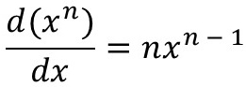
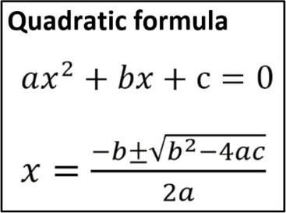
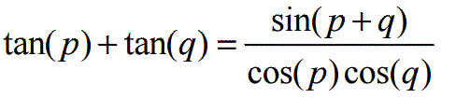
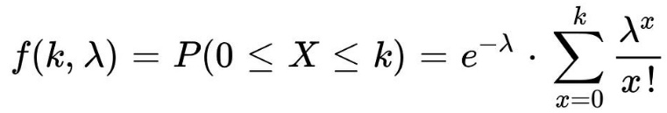
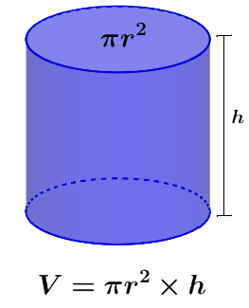

To simplify your task and understanding, we use variables in much the same way as in mathematics.
We usually do the following:
- We state what the variable is (an integer, a decimal, a text…?)
- We give the variable real values (often multiple times). This can be define IN the program (static writing) or changed by the user (dynamic input).
NOTE: Just like in mathematics, there is NO NEED to state WHEN you’re done done with a variable and won’t use it again.
Even though, dynamic spatial variable (variable shaped array, etc…) can free the space they occupy on command.
This is unfortunately one of the most downside of the C-language: it doesn’t have a proper gestion of the leftover variables (what we call technically a “Garbage Collector”).

In C, you can declare a variable using the following template:
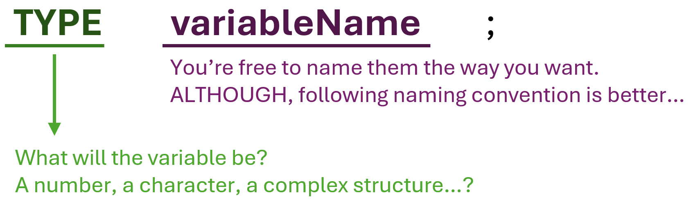

B. The scalar type table
Some types have been reduced to their minimalist form.
For example: the “short” type can also be written in 3 ways:
- short short int
- short signed short
- short signed short int
Therefore, for simplicity, we’ve kept only the most iconic and simplest form for each type.

Scalar Types
Type category | Type  (C-syntax) | Format specifier | Description | Data range
Integer | short | %hi | Small integer (≥ 4 bits) | [−32 767 ; +32 767]
Integer | unsigned short | %hi | Small integer (≥ 4 bits) | [0 ; 65 535]
Integer | int | %i | Basic integer (≥ 16 bits) | [−32 767 ; +32 767]
Integer | unsigned int | %u | Basic integer (≥ 16 bits) | [0 ; 65 535]
Integer | long | %li | Long integer (≥32 bits) | [−2 147 483 647 ; +2 147 483 647]
Integer | unsigned long | %lu | Long integer (≥32 bits) | [0 ; 4 294 967 295]
Integer | long long | %lli | Long integer (≥64 bits) | [−9 223 372 036 854 775 807 ; +9 223 372 036 854 775 807]
Integer | unsigned long long | %llu | Long integer (≥64 bits) | [0 ; 18 446 744 073 709 551 615]
Character (processed as integer) | char | %c | Basic character. Processed as an integer behind the scenes (ASCII).  Can be positive or negative. (≥ 4 bits) | [−127 ; +127] (signed)  [0 ; 255] (unsigned)
Character (processed as integer) | signed char | %c |  | [−127 ; +127]
Character (processed as integer) | unsigned char | %c |  | [0 ; 255]
Real  (decimal) | float | %f | (≥32 bits)
Real  (decimal) | double | %lf | (≥64 bits)
Real  (decimal) | long double | %lf | (≥128 bits)
Boolean | bool | %d | A true/false variable (1 bit) | [false ; true]

04. INPUT/OUTPUT (I/O)
So far, you have been using the “O” for Output quite a bit… using the “printf(…)” function: it gives off feedback to the user. This is essentially the program talking to YOU!
There are many ways for a program to output something, this can be a whole chapter.

_I/O_ stands for “Input / Output”.
If you imagine your program as a physical machine, this refers to:
- What you’re going to “feed” into your machine (a date, multiple values in a file, keyboard inputs…)
- what the program is giving you back (a text on your display, sound, saving a file…) after being executed.
This is a term widely used in the information technology field. You are going to find it a lot in many documentations and wikis.

For this chapter:
- We’re going to see further use and format for the “printf()” function… Also, what does “printf” really means!
- THEN, we’re going to get some INPUT to our program, this is the interesting part. This will make your programs dynamic to what the user want to input.

0X. TECHNICAL SPECIFICATION SHEET

A. REFERENCES
I am using multiple documents to find inspiration and guidance in the making of my courses.
Here is everything I have used for this one. (TODO: rewrite this one, to make it more neutral without “I”)

Books:
- …

Websites / Online documentation:
- Canva: https://www.canva.com/ For the front page and some exercise banner designs
- WordReference: https://www.wordreference.com/ Translation: French <> English
Formule de poisson :
https://medium.com/data-science/2-functions-you-should-know-before-using-poisson-distribution-d470db790bfc
Derivative formula:
https://www.teachoo.com/9722/1227/Differentiation-Formulas/category/Finding-derivative-of-a-function-by-chain-rule/
Trigo
https://jeretiens.net/les-formules-de-trigonometrie-facile/
Cours prépa maths (inspiration formules):
https://www.mathprepa.fr/cours-mpsi-pcsi/

Software / Tools:
- IDE (C programming): Used for screenshots, programming and testing.
  - CLion (JetBrains)
  - Code::Blocks
  - Visual Studio Code (Microsoft)
- Artificial Intelligence: Help in designing the syllabus and create original exercises.
  - ChatGPT (OpenAI)
  - Gemini (Google)
- Writing/Editing software: Creating my courses, exercises, presentations…
  - PowerPoint (Microsoft)
  - Word (Microsoft)

B. DOCUMENT SPECIFICATIONS

TECHNICAL INFORMATION
Document Version | 1.0
Release Date (YYYY.MM.DD) | 2025.09.27
Course Title | C-LANGUAGE & ALGORITHM
Chapter Name | Chapter 02 - Scalar types and simple I/O
Document ID | PROG-C-A-002
Keywords | C, IDE, program, worksheet, course materials, digital
File Name | C-Chapter02-typeIO-v1.0.pdf
Page Count | 12 pages
Contributors | - Nathalie AMSALLEM: Proofreader  - Léo BELUITE: Proofreader  - Drazic MARTIN: Proofreader and program tester  - Simon Céleste VANDAMME: Author
Maintainer Contact | celeste.vandamme@outlook.com
Target Audience | Designed for engineering students starting to learn the C-programming language.
Languages Available | - English: available  - French: not yet available
Answer Sheet | Not yet available
Confidentiality Level | Public
License | Creative Commons Attribution 4.0 International  (CC BY 4.0)  Link: https://creativecommons.org/licenses/by/4.0/



VERSION HISTORY
Version | Release Date (YYYY.MM.DD) | Authors | Description / What is new in the version?
1.0 | 2025.09.27 | - VANDAMME S. | Official release of the document.

Multiple specifier can exists for the same type (example: %i and %d for the int)
The number of bits depends on the architecture of the OS. The number of bit in these descriptions is the usual amount you could expect, but it highly vary from one system to another.
The range is directly dependent to the number of bit attributed.

